**Lab 6**

***(Show input and output side by side for all problems****)*

1. 1. Apply three types of highpass filtering in the frequency domain on Figure 1;

i. Ideal highpass filter (IHPF)

ii. Butterworth highpass filter (BHPF)

iii. Gaussian highpass filter (GHPF)

1. Apply three types of lowpass filtering in the frequency domain on Figure 1;

i. Ideal lowpass filter (ILPF)

ii. Butterworth lowpass filter (BLPF)

iii. Gaussian lowpass filter (GLPF)

1. Accurate diagnosis is the most vital part of the healthcare sector. For a precise diagnosis, the test results must display the features as clearly as possible. According to your observations while solving the previous problems, which filtering technique would you choose if you were given the task of performing image enhancement on the given image? Explain and justify your reasoning.
2. Apply Hough transform to Figure 2 and draw the detected lines on the original image.

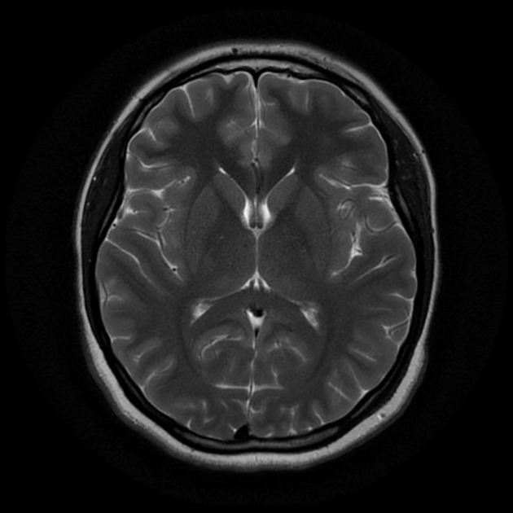

**Figure 1:** Brain MRI

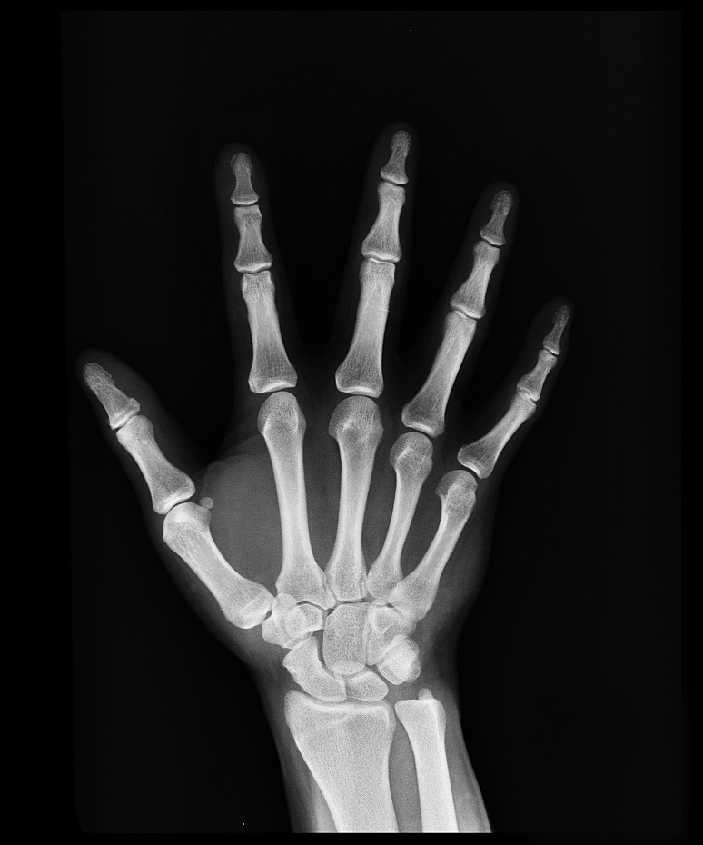

**Figure 2:** X-Ray Image